SUMIF_Store data:
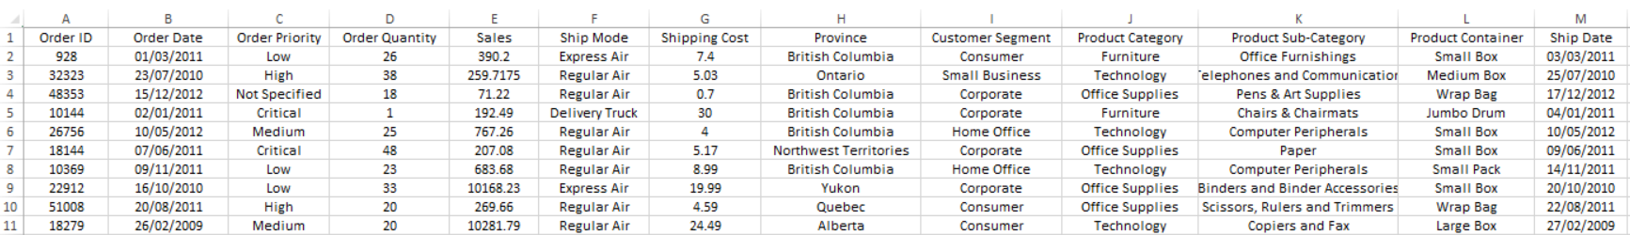

Ontario Total Sales: =SUMIF(StoreSalesTable[Province], "=Ontario", StoreSalesTable[Sales])
Furniture Total Sales: =SUMIF(StoreSalesTable[Product Category], "=Furniture", StoreSalesTable[Sales])
